APP DYNAMICS DASHBOARD:
dashboard and reports -> create dashboard.
Q. How this looks like?
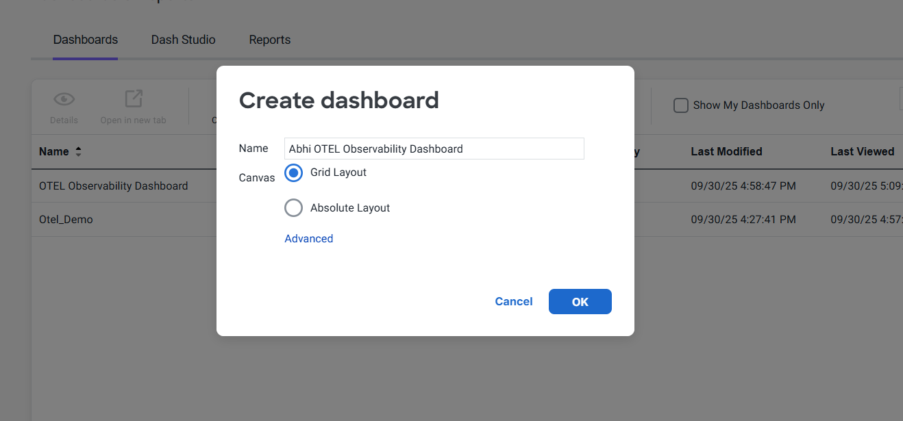
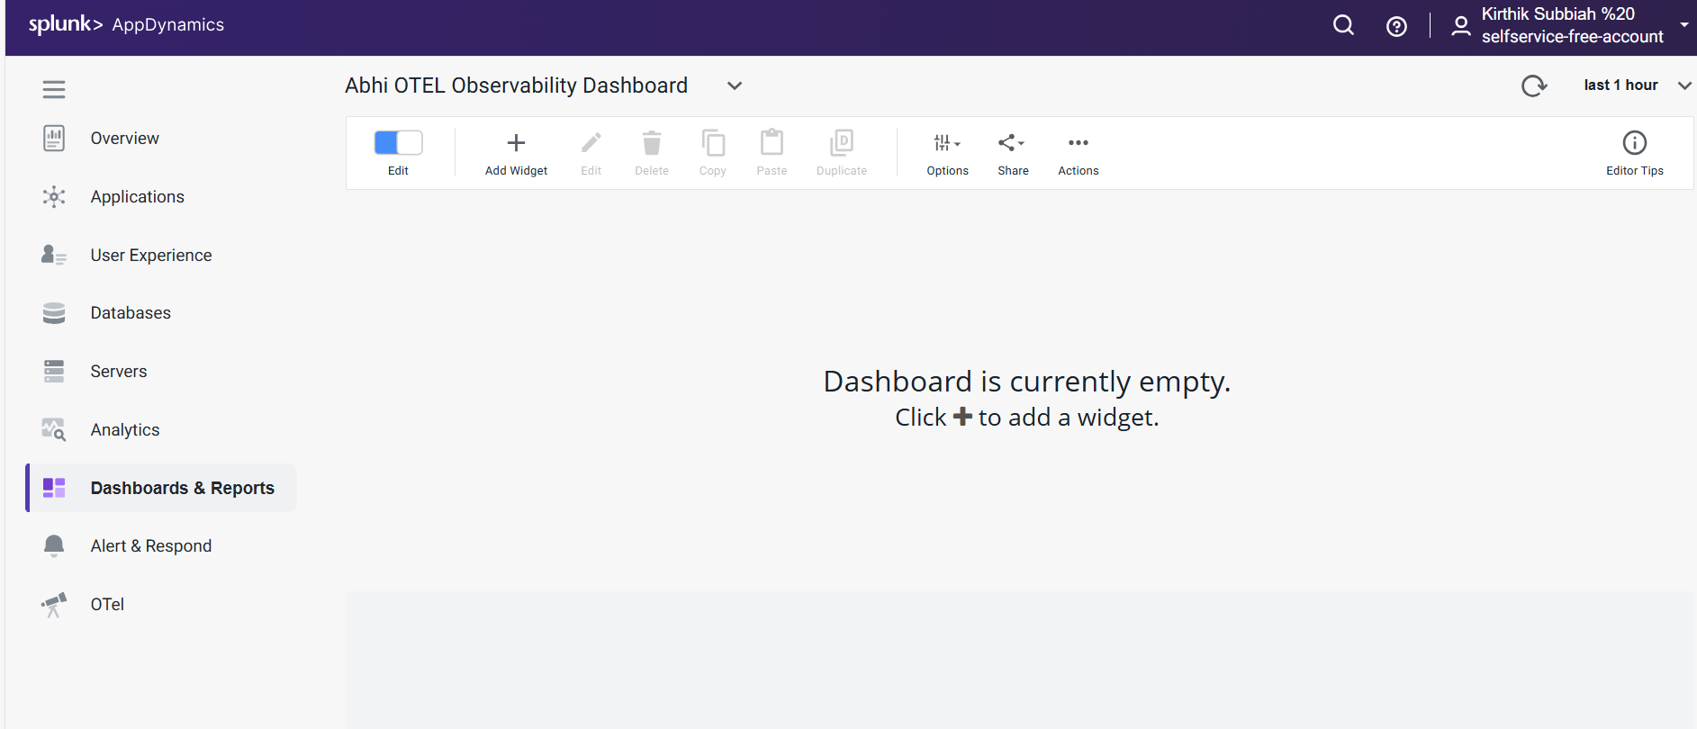

Q. How to see what type of data are u using for create this dashboard?
Applications -> U can see
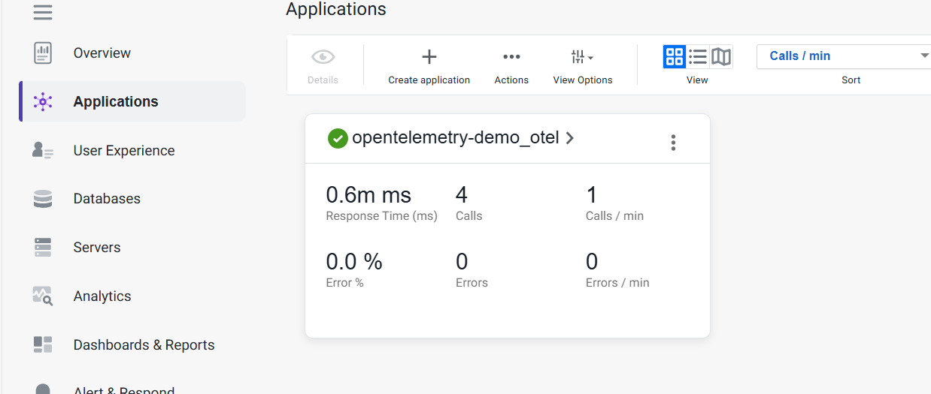
Q. How to add widgets?
Add widget -> Time series graph
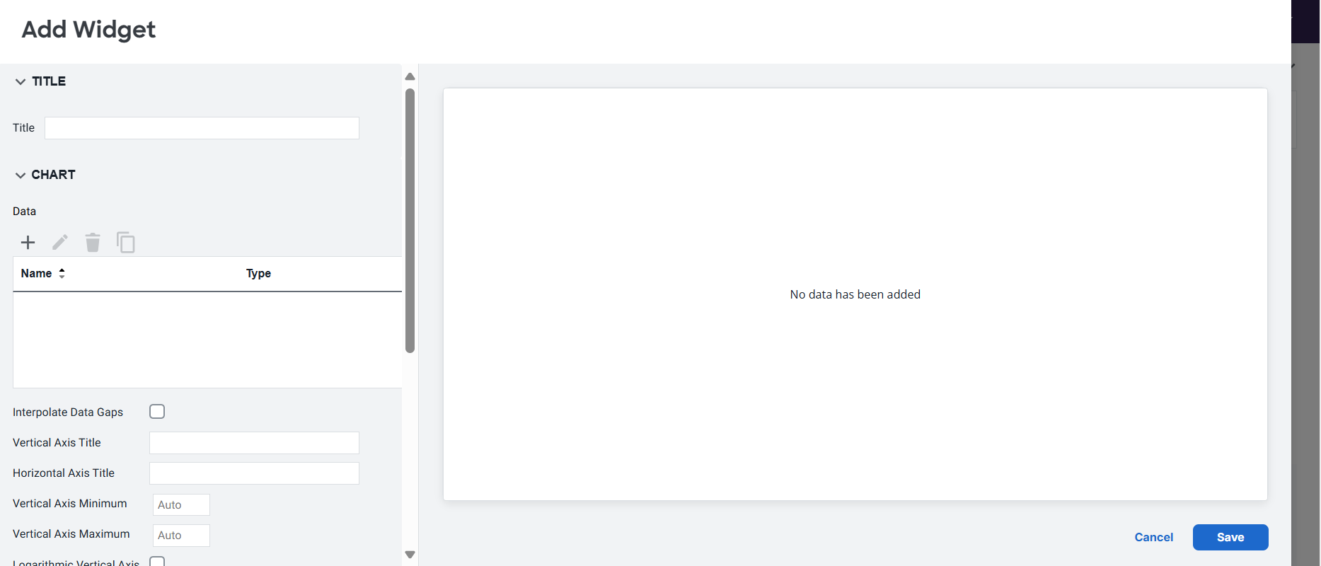
click on the + so you can see data
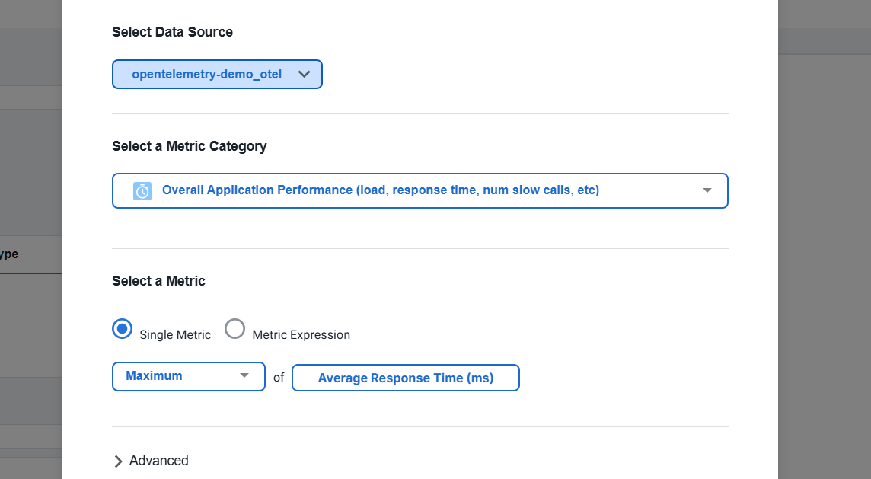
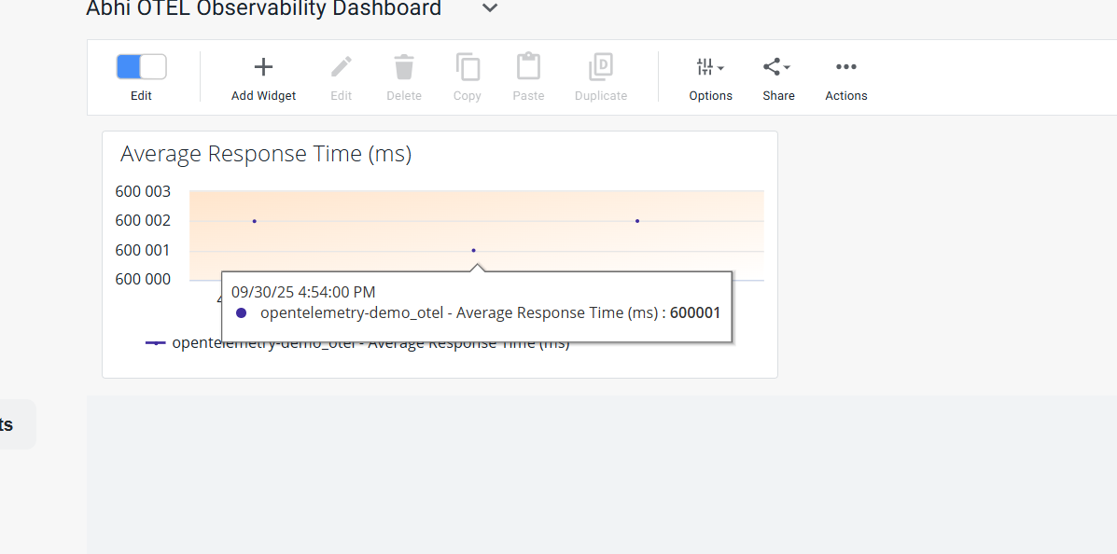
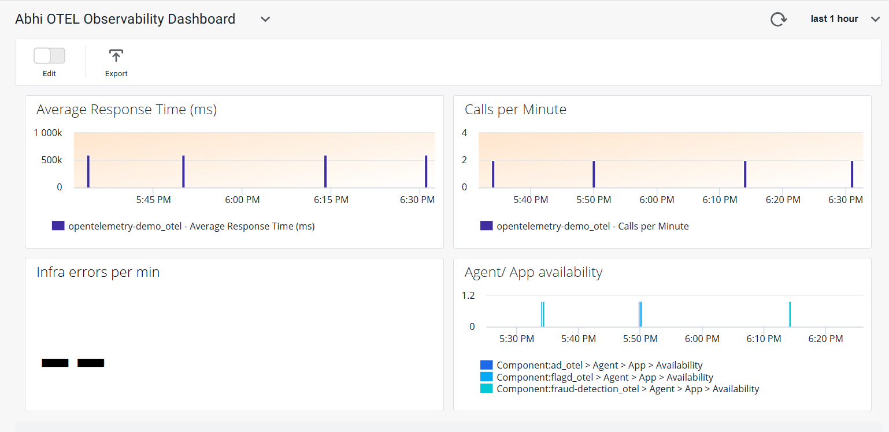
PROBLEMS:
vdo link: https://youtu.be/coE4Vp-F-4A?si=v9Y_hW0FttYXAmls
- When I take application : no data can be seen in application dashboard and all others:
Only top business transactions shows some data but not aware about whats that.
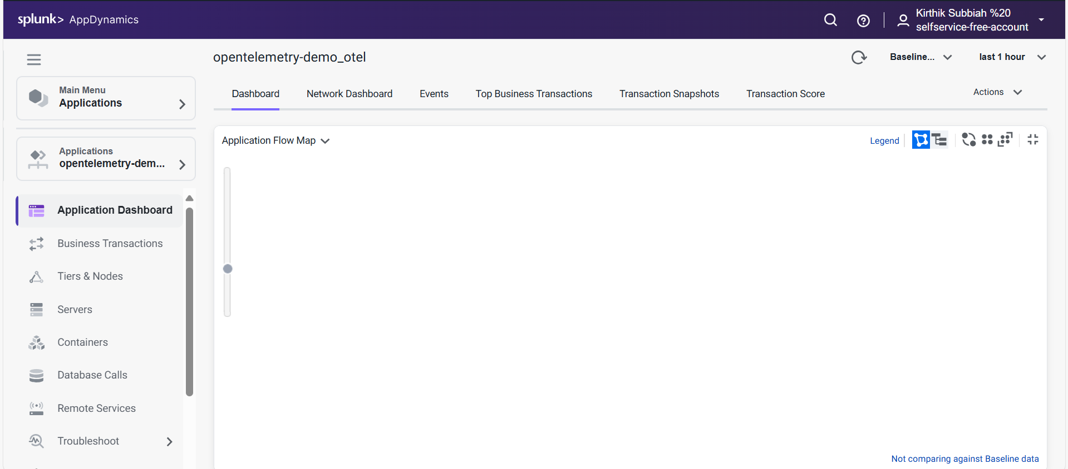
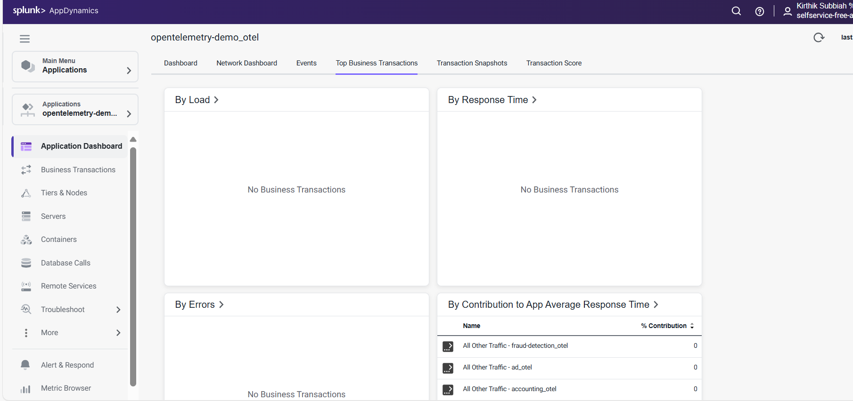
Solution: Change the time range to 1 year .
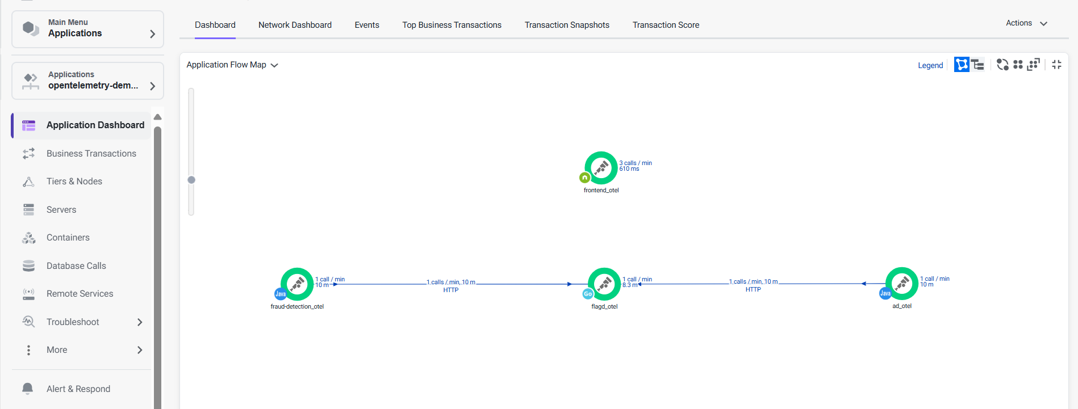
Q. Tiers and nodes:
Ans: Helps to check health of the services.

Q. Remote services:
If ur app is using any remote services that can be registered here.
Q. war rooms?
To share info with other peoples.

OPENTELEMETRY TRAININGS: Getting Started with OpenTelemetry (LFS148) - Linux Foundation - Education

Useraname: abhiramikannan
